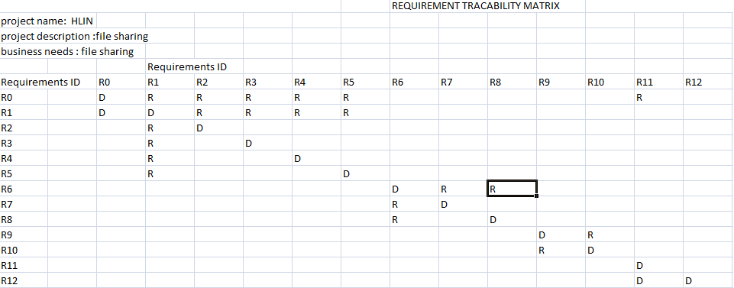

Requirement Id Function description

R0 file encrypt and upload Owner uploads the file

R1 type of lock Owner has to choose the type of

lock

R2 password File is secured with Password

R3 geo-lock File can be accessed in specific

geographical location .

R4 network lock File can be accessed through

specific network

R5 none File has no security. Generally

not preferred

R6 managing file Owner can change the settings

of the file

R7 delete file Owner can delete the file.

R8 change lock Owner can change the

accessibility of file

R9 generate key Cloud generates the unique access key for the uploaded file

R10 stores files uploaded Uploaded files are stored in the cloud.

R11 sends access key to receiver manually Owner has to send the

access key to the receiver

manually

R12 download file Receiver can download the file with a

valid acess key